13.12: a) From Eq. (13.19), 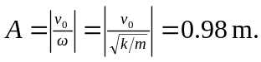 b) Equation (13.18) is
indeterminant, but from Eq. (13.14), 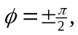 and from Eq. (13.17), sin 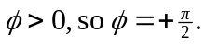
c)

